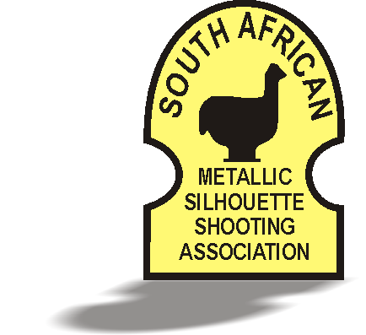
SUID-AFRIKAANSE METAALSILHOEËT SKIETVERENIGING
SOUTH AFRICAN METALLIC SILHOUETTE SHOOTING ASSOCIATION

(+27) 73 304 7510 Fax: (+27) 86 670 5337 e-mail: secretary@samssa.org.za PO Box 31165, Fichardtpark, 9317, South Africa

Invitation
to the 12th IMSSU World Championship

SAMSSA is delighted to invite all of the IMSSU member countries to compete in the 12th IMSSU World Championship 2016.

The competition will be held on the Bloemfontein Metallic Silhouette Shooting range from 2 – 16 July 2016.

SAMSSA will be hosting the following 16 IMSSU events:
- Big Bore Handgun: Production, Revolver, Standing and Unlimited
- Small Bore Handgun: Production, Revolver, Standing and Unlimited
- Field Pistol: Production and Production Any Sights
- Big Bore Rifle: Hunting and Silhouette
- Small Bore Rifle: Light and Silhouette
- Production Air Pistol Standing
- Production Air Rifle Standing

SAMSSA will be hosting the following non-IMSSU events:
- Small Bore Rifle Light Open Sights
- Small Bore Rifle Silhouette Open Sights
- Varmint Handgun Any Sights

SAMSSA will be hosting an U21 competition for:
- Small Bore Handgun: Production, Revolver, Standing and Unlimited
- Small Bore Rifle: Light and Silhouette

