The 12th IMSSU World Championship will be hosted by SAMSSA, in collaboration with the Bloemfontein Metallic Silhouette Shooting Club, during the period 2-16 July 2016 on the Bloemfontein Shooting Center just outside Bloemfontein, South Africa.
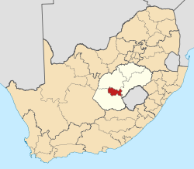
The Bloemfontein Shooting Center is situated in the Manguang Metro Municipality. Mangaung is the Sesotho word for “place of the Cheetahs”.

Bloemfontein is the capital of the province Free State of South Africa and is the judicial capital of the nation.

Bloemfontein is popularly known as the city of roses, owing to the abundance of these flowers and the annual rose festival held there. Bloemfontein is situated on dry grassland and is home to 369 568 residents.

Bloemfontein is located in central South Africa on the southern edge of the Highveld at an elevation of 1,400 metres (4,600 ft), bordering on the semi-arid region of the Karoo. The area is generally flat with occasional hills (koppies in Afrikaans) and the general vegetation is Highveld grassland. Bloemfontein experiences a semi-arid climate, with hot summer days (Jan: max:32 °C (90 °F) min:19 °C (66 °F); frequent afternoon thunderstorms) and cooler, dry winters, often with frosts (July: max:14 °C (57 °F) min:−3 °C (27 °F)). Snow is uncommon but as recently as August 2006 it snowed in the city, with snowfalls occurring again at the airport on 26 July 2007.
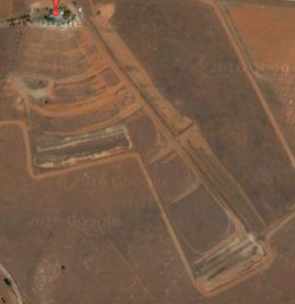
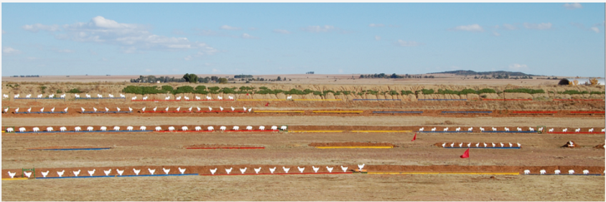
The event will be hosted on the Bloemfontein Metallic Silhouette Shooting Range, 18km south for Bloemfontein, which is part of the larger Bloemfontein Shooting Center.

SAMSSA will be hosting the following 16 IMSSU events:
- Big Bore Handgun: Production, Revolver, Standing and Unlimited
- Small Bore Handgun: Production, Revolver, Standing and Unlimited
- Field Pistol: Production and Production Any Sights
- Big Bore Rifle: Hunting and Silhouette
- Small Bore Rifle: Light and Silhouette
- Production Air Pistol Standing
- Production Air Rifle Standing

Additionally, SAMSSA will be hosting the following non-IMSSU events:
- Small Bore Rifle Light Open Sights
- Small Bore Rifle Silhouette Open Sights
- Varmint Handgun Any Sights

SAMSSA will also be hosting an U21 competition for:
- Small Bore Handgun: Production, Revolver, Standing and Unlimited
- Small Bore Rifle: Light and Silhouette
- Production Air Pistol Standing
- Production Air Rifle Standing

All events will be a 40 +5 shot event, except for Small Bore Rifle which will be conducted as 2 40 (+5) shots events. Shoot-offs will be shot in five shot strings.

The provisional program is:
- Practice: 2 - 4 July
- BBHG: Tue 5 - Fri 8 July
- SBHG: Sat 9 - Wed 13 July
- FP: Sat 9 - Wed 13 July
- BBR: Mon 11 - Wed 13 Jul
- SBR: Tue 5 - Wed 13 Jul
- Shootouts - Thu 14 July
- IMSSU Assembly - Fri 15 July
- Awards Function: Fri 15 July

Medals and Awards:
- Big Bore Handgun Revolver: Overall, I-class, A-class, B-class
- Big Bore Handgun Production: Overall, I-class, A-class, B-class
- Big Bore Handgun Standing: Overall, I-class, A-class, B-class
- Big Bore Handgun Unlimited: Overall, I-class, A-class, B-class
- Big Bore Handgun 160-shot Aggregate: Overall
- Big Bore Handgun 160-shot Aggregate: Teams

- Small Bore Handgun Revolver: Overall, I-class, A-class, B-class, Junior U21
- Small Bore Handgun Production: Overall, I-class, A-class, B-class, Junior U21
- Small Bore Handgun Standing: Overall, I-class, A-class, B-class, Junior U21
- Small Bore Handgun Unlimited: Overall, I-class, A-class, B-class, Junior U21
- Small Bore Handgun160-shot Aggregate: Overall, Junior U21
- Small Bore Handgun160-shot Aggregate: Teams

- Field Pistol Production: Overall, I-class, A-class, B-class
- Field Pistol Production Any Sights: Overall, I-class, A-class, B-class
- Field Pistol 80-shot Aggregate: Overall
- Field Pistol 80-shot Aggregate: Teams

- Handgun Standing 160-shot Aggregate: Overall
- Handgun Standing 160-shot Aggregate: Teams

- Big Bore Rifle Hunting: Overall, I-class, M-Class, A-class, B-Class
- Big Bore Rifle Silhouette: Overall, I-class, M-Class, A-class, B-Class
- Big Bore Rifle 80-shot Aggregate: Overall
- Big Bore Rifle 80-shot Aggregate: Teams

- Small Bore Rifle Light: Overall, I-class, M-Class, A-class, B-Class, Junior U21
- Small Bore Rifle Silhouette: Overall, I-class, M-Class, A-class, B-Class, Junior U21
- Small Bore Rifle 160-shot Aggregate: Overall, Junior U21
- Small Bore Rifle 160-shot Aggregate: Teams

- Air Rifle Production Standing: Overall, Junior U21
- Air Pistol Production Standing: Overall, Junior U21

- Small Bore Rifle Light Open Sight: Overall, Junior U21
- Small Bore Rifle Silhouette Open Sight : Overall, Junior U21
- Varmint Handgun: Overall

Medals and Awards:
- 45€ per IMSSU event (10% discount if paid before 31 March 2016)
- 15€ per SAMSSA (additional) event (10% discount if paid before 31 March 2016)
- 20€ per person attending awards function
- 75€ per team per aggregate

Banking details
Account Name: SAMSSA Swift Code: ABSA ZA JJ
Bank: ABSA Bank Branch: Fichardtpark
Account Number: 4055410587 Branch Code: 632005
Payment Reference: For individuals use Surname and initials, for bulk payment use country name

Entries close 31 April 2016.
Entries to be emailed to secretary@samssa.org.za, including proof of payment.
12th IMSSU WORLD CHAMPIONSHIP
Individual Entry Form
(Please, type in or write in upper-case letters.)

Federation or Association:

Family name: Given names:

Adress:

E-Mail: Phone:

Date of Birth:

Date of arrival: Date of departure:

ENTRY FEES ARE 45 EUROS PER IMSSU EVENT. A DISCOUNT OF 10% APPLIES SHOULD THE ENTRY AND CORRECT PAYMENT BE RECEIVED BEFORE 31 MARCH 2016. ENTRIES CLOSES 30 APRIL 2016

MY STARTS – IMSSU Events
 | Discipline | Start (yes/no) | Class | Name of my spotter (only if he/she is  a competitor) | If the gun will be shared - name of the competitor I will share my gun with:
1 | Big Bore Pistol - Revolver
2 | Big Bore Pistol - Production
3 | Big Bore Pistol - Standing
4 | Big Bore Pistol - Unlimited
5 | Small Bore Pistol - Revolver
6 | Small Bore Pistol - Production
7 | Small Bore Pistol - Standing
8 | Small Bore Pistol - Unlimited
9 | Field Pistol - Production
10 | Field Pistol – Any Sight
11 | Small Bore Rifle - Light
12 | Small Bore Rifle - Silhouette
13 | Big Bore Rifle - Hunting
14 | Big Bore Rifle - Silhouette
15 | Air Pistol
16 | Air Rifle
 | Total number of starts:

ENTRY FEES ARE 15 EUROS PER NON-IMSSU EVENT. A DISCOUNT OF 10% APPLIES SHOULD THE ENTRY AND CORRECT PAYMENT BE RECEIVED BEFORE 31 MARCH 2016. ENTRIES CLOSES 30 APRIL 2016
MY STARTS – Non IMSSU Events
 | Discipline | Start (yes/no) | Name of my spotter (only if he/she is  a competitor) | If the gun will be shared - name of the competitor I will share my gun with:
17 | Small Bore Rifle Open Sights - Light
18 | Small Bore Rifle Open Sight - Silhouette
19 | Varmint Handgun
 | Total number of starts:

THE AWARDS FUNCTION WILL BE HOSTED ON FRIDAY 16 JULY 2016. THE FEE FOR ATTENDING THE FUNCTION IS 20 EUROS. A DISCOUNT OF 10% APPLIES IF CORRECT PAYMENT IS RECEIVED BEFORE OR ON 30 MARCH 2016.

NUMBER OF PEOPLE TO ATTEND AWARDS FUNCTION

Please send this form back to e-mail secretary@samssa.org.za no later than 30 April 2016.

